**Project Name**

Graphic Designing and Resume

**Project Analytics**

|  |  |
| --- | --- |
| **Poster** | **Colour pallatel** |
| **Page layout** | **T shirt logo making** |
| **Grid making** | **Animation** |
| **Graphic design** | **Logo and pie chart** |

**TEAM MEMBERS AND WORK**

**B.Vinthiya**

* **Page layout and T shirt logo making**

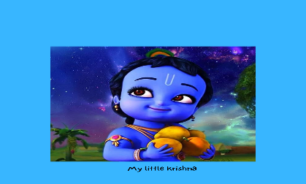

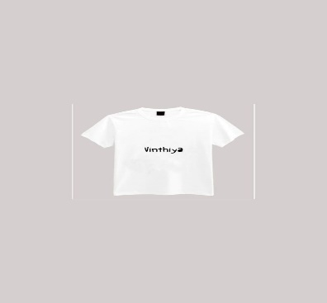

**M.Iswarya**

* Grid Making and Animation

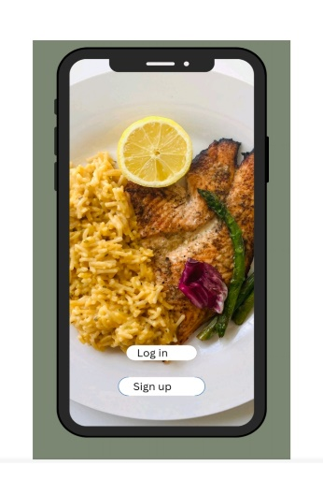



**V.Veera lakhmi**

* Graphic design and logo making





**R.Aruna Sri**

* Pie chart and Ad making

